**7. Convert Celsius and Fahrenheit using function**

**PROGRAM:**

#include <iostream>

double celsiusToFahrenheit(double celsius) {

return (celsius * 9.0 / 5.0) + 32.0;

}

double fahrenheitToCelsius(double fahrenheit) {

return (fahrenheit - 32.0) * 5.0 / 9.0;

}

int main() {

double tempCelsius, tempFahrenheit;

int choice;

std::cout << "Temperature Conversion Program" << std::endl;

std::cout << "1. Convert Celsius to Fahrenheit" << std::endl;

std::cout << "2. Convert Fahrenheit to Celsius" << std::endl;

std::cout << "Enter your choice (1 or 2): ";

std::cin >> choice;

if (choice == 1) {

std::cout << "Enter temperature in Celsius: ";

std::cin >> tempCelsius;

tempFahrenheit = celsiusToFahrenheit(tempCelsius);

std::cout << tempCelsius << "°C is " << tempFahrenheit << "°F" << std::endl;

} else if (choice == 2) {

std::cout << "Enter temperature in Fahrenheit: ";

std::cin >> tempFahrenheit;

tempCelsius = fahrenheitToCelsius(tempFahrenheit);

std::cout << tempFahrenheit << "°F is " << tempCelsius << "°C" << std::endl;

} else {

std::cout << "Invalid choice. Please enter 1 or 2." << std::endl;

}

return 0;

}

**OUTPUT:**

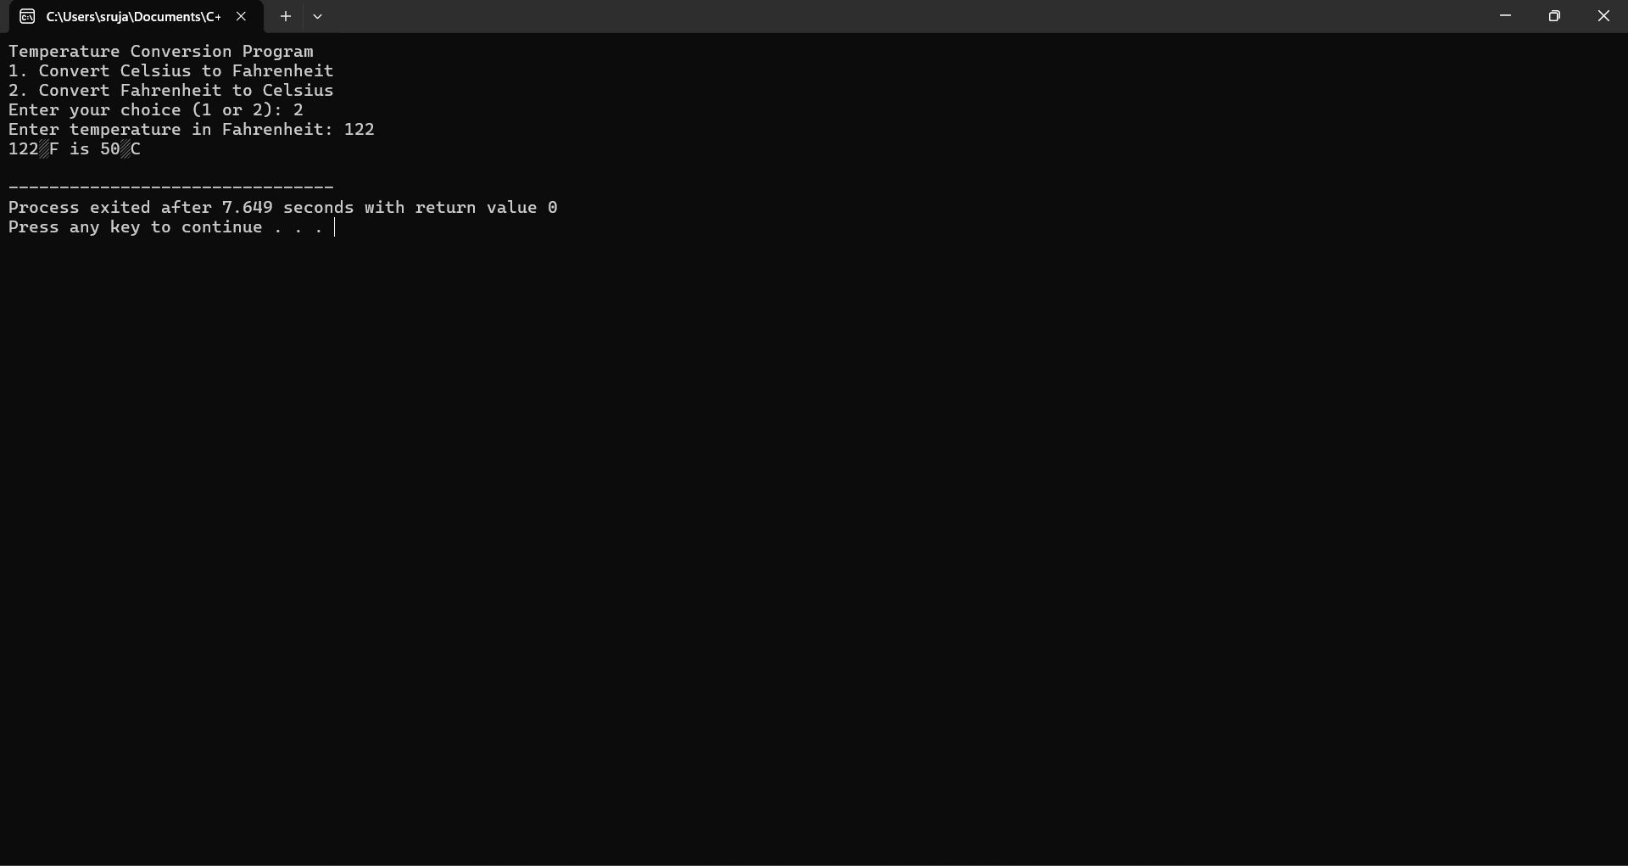

**8.Find the area of a circle using function**

**Program:**

#include <iostream>

#include <cmath> /

double calculateArea(double radius) {

return M_PI * radius * radius;

}

int main() {

double radius;

std::cout << "Enter the radius of the circle: ";

std::cin >> radius;

if (radius < 0) {

std::cout << "Radius cannot be negative." << std::endl;

} else {

double area = calculateArea(radius);

std::cout << "The area of the circle with radius " << radius << " is " << area << std::endl;

}

return 0;

}

**OUTPUT:**

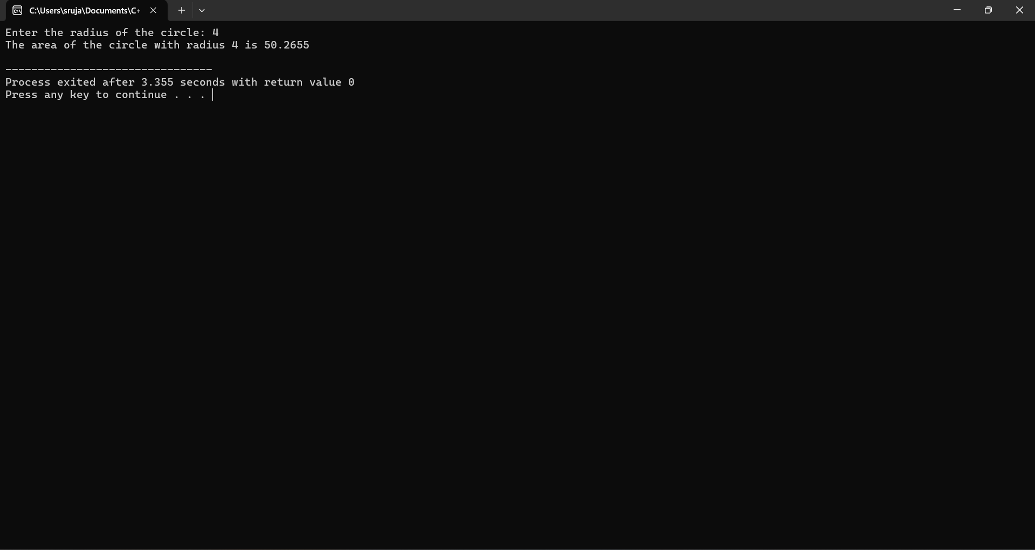

**9.Check whether the string is palindrome or not using function**

**PROGRAM:**

#include <iostream>

#include <string>

#include <algorithm>

bool isPalindrome(const std::string& str) {

std::string reversedStr = str;

std::reverse(reversedStr.begin(), reversedStr.end());

return str == reversedStr;

}

int main() {

std::string input;

std::cout << "Enter a string: ";

std::getline(std::cin, input);

if (isPalindrome(input)) {

std::cout << "\"" << input << "\" is a palindrome." << std::endl;

} else {

std::cout << "\"" << input << "\" is not a palindrome." << std::endl;

}

return 0;

}

**OUTPUT:**

